SQL
Video 1
A link between a main table and a sub group is called a relationship
One to many
Primary key is the first / “unique” field in each table
Secondary keys used for searching

Video 2 – Methods of capturing data
OCR – Optical character recognition, technology that automatically scans text by interpreting the shapes of letters. Works better with printed text rather than handwritten text.

EDI - Electronic Data Interchange, a non-manual way of exchanging data, a protocol for 2 systems to automatically exchange data I.e. automatically ordering stock once it`s identified a supply is running low.

Transaction processing:
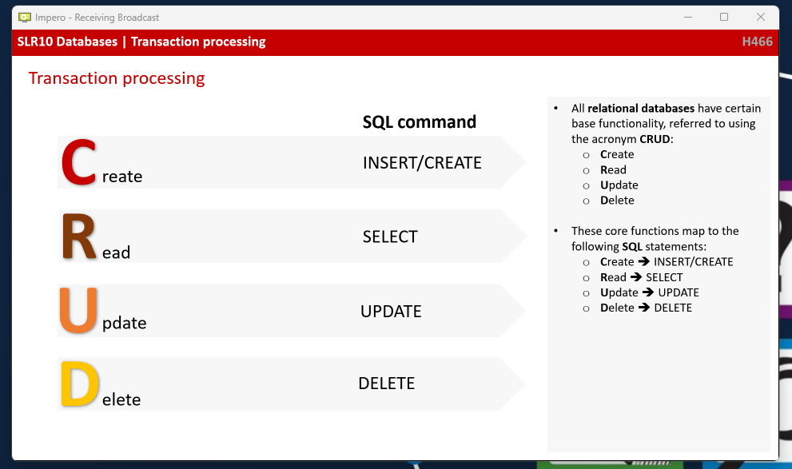
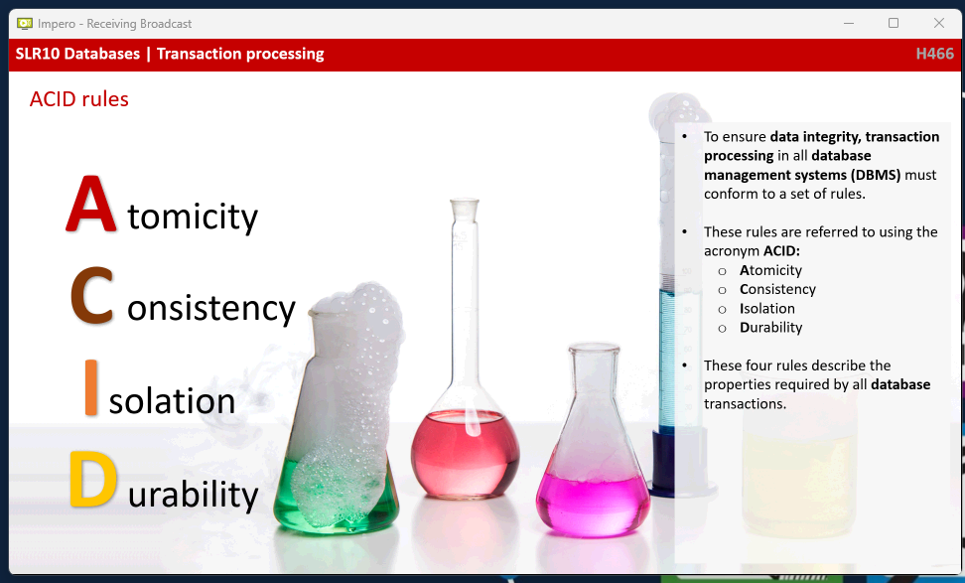
Atomicity: Either completely finished or not touched database, can`t be saved halfway through a process
Consistency: If there is a change, everything must be the same total so money doesn’t vanish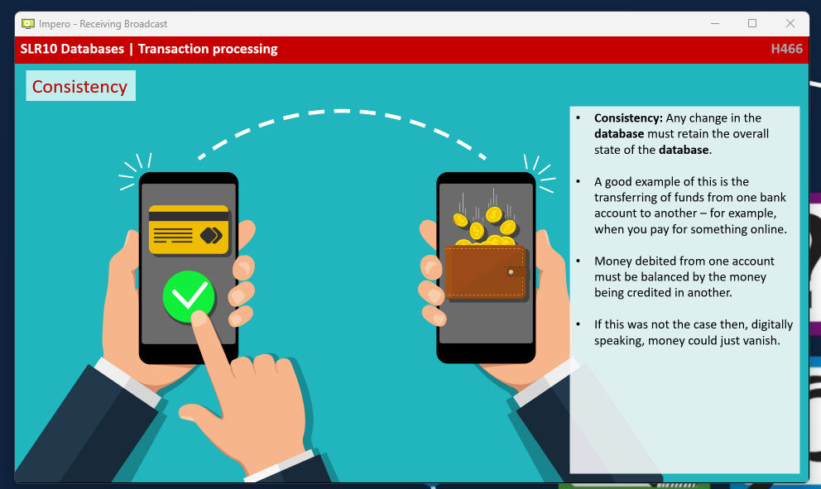
Isolation: Only one user can do a transaction at a time
Durability: Ensuring no data is lost while saving, leaving it in secondary storage.

